**OIL DOWN**

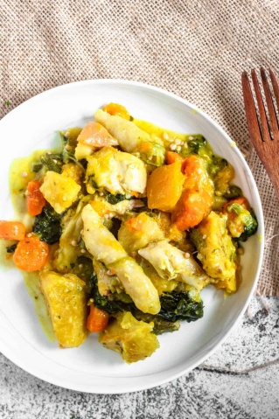

**INGREDIENTS**

2 lb Salted Pigtail

1 Lemon cut in half

2 lb Chicken Wings, or chicken backs etc

½ cup Green Seasoning, See recipe here

4 cups Coconut Milk, make it fresh if you can. If not, you can use canned

3-4 tsp Ground Turmeric, use fresh if you can find it

1 lb Breadfruit, cut into chunks

2 Green bananas, sliced

4 Carrots, peeled and sliced into rounds

1 lb Pumpkin, cut into chunks

1 ½ cups Okra, cut in half

5 oz Spinach, use Callaloo instead if you can find it

1 tsp Salt

**Dumpling**

1 cup all purpose Flour, + 1-2 tbsp if necessary

½ tsp Salt

¼ cup Water

**METHOD**

1. Fill a large pot with water, 2 halves of (1) lemon, and 2 lb salted pigtail. Bring the water to a boil, and boil for about 25 minutes. When the timer is done, drain the pigtails.
2. In a small bowl, combine the 2 lb chicken and ½ cup green seasoning. Cover and set in the fridge.
3. In a large bowl, whisk 4 cups coconut milk with 3-4 tsp ground turmeric. If you can find fresh turmeric, blend the turmeric and coconut milk in a blender. Set aside.
4. Using a very large pot, add chicken (and green seasoning marinade) to the bottom of the pot. Layer the boiled pigtails on top of the chicken.
5. Next, add the prepared 1 lb breadfruit, 2 green bananas, 4 carrots, 1 lb pumpkin, and 1 ½ cups okra, and 1 tsp salt. Pour the coconut milk + turmeric combination over the entire contents of the pot.
6. Lastly, put 5 oz greens (spinach or callaloo) at the top of the pot. Cover the pot with a lid and cook over medium heat for 25 minutes. Do not stir.
7. When there are about 10 minutes left on the timer, start making the dumplings. To do so, add 1 cup all purpose flour, ½ tsp salt, and ¼ cup water to a small bowl. Knead the combination until smooth dough forms that is not sticky but also not dry or crumbly.
8. Roll the dough into dumplings the shape and size of your pinky finger. When the 25 minute timer is up, put the dumplings at the top of the pot, on top of the spinach.
9. Cover the pot again and allow it to cook for another 30-45 minutes. Do not stir.
10. When the timer is done, take the lid off of the pot. Make sure that there is a small amount of liquid left in the bottom of the pot. Now you can stir it and serve! Enjoy!